**OCEAN CHARTER 25-26 BUDGET ASSUMPTIONS - (updates since last meeting in blue)**

* Enrollment – 558, ADA rate – 94.5% (prev. 94%)
* Revenue COLA – 2.43%
* Grant Revenues included:
  + ELO-P - $206,286
    - 25-26 entitlement - $205,458
    - Carryover from 24-25 - $51,431, carryover allowed up to 2 years.
  + Educator Effectiveness - $49,209 (prev. $10,026)
    - Total entitlement - $117,818,
    - Allocations: FY22-23 - $23,528, FY23-24 - $10,285, FY24-25 -$34,796 (prev. $73,979), FY25-26 – $49,209 (prev. $10,026)
    - Funds to be spent by 6/30/2026.
  + State Mental Health – $42,670 (increased by $17K)
    - Total entitlement - $42,670
    - Informal counseling expenses tagged
  + Prop 28 – $76,943 (increased by $4K)
    - Total funding $120,372
    - 25-26 funding- $72,249 + Prior-year carryover 48,123
  + Arts & Music Block grant – $63,555 (increased by 6K)
* Universal meals funded
* Fundraising - $436,955 (same as FY24-25) 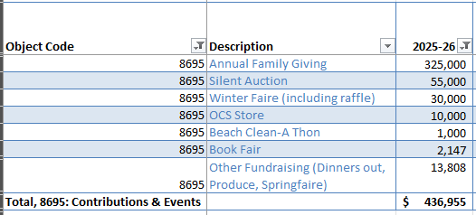
* Aftercare & enrichment revenue - $486,139
  + Aftercare - $378,139
  + Enrichment revenue - $108,000
* Interest and Dividend income – $30,625 ($20,625 earned through 01/2025)
* Expense COLA – 3% applies to materials and services.
* Salary Increases – All staff including OCTA Schedule increased by 2.5% (prev. 1%) and OCTA STEP & Column movement included (OCTA movement for specialty teachers now included)
* Intervention - One of the intervention teacher positions (vacant in 25-26) adjusted from 60% to 100% (FTE) and estimated salary reduced by $17K.
* STRS Employer rate – 19.10%
* Health & Welfare rate – 8% increase included
* Maintain reductions made to one-time positions previously funded with COVID and Learning Loss in 21-22, 22-23 and 23-24:
  + Keeping TK(2) and Kinder aides(2) and other aides(8) which are a combination of intervention and classroom assistants.
* ExED Fee - $150,000 CALPADS services fee $17,700
* Expense adjustments (based on FY24-25 actuals):
  + All other consultants $242,365 (reduced by 5K)
  + Non-instructional consultants $36,886 (reduced by 10K)
  + Office phone $10,881 (reduced by 9K)
  + Internet $20,384 (reduced by 6K)
  + Website hosting $4,920 (reduced by 5K)
* Special Ed Fair Share $473,893 (increased by $78K due to district fee increase)
* Prop 1D loan payments - $466,074
* Over-allocation fee $148,145
* Dennis Demanett Mentoring reduced by $2K
* Circle ways Trauma informed training reduced by $1.5K
* OCTA mentoring stipends reduced by $2.5K
* Total Net Income (with $1.4M site depreciation) -$1,064,853 (increased by 15K))
* Net Income – OPERATING - $398,412 (increased by $15K)
* Debt service coverage ratio – 1.26 (prev. 1.23)
* Cash Balance as of 6/30/26 - $2,003,142 (decreased by 281K)
* Cash Reserve (cash balance as a % of total expenses) – 22% (prev. 25.3%)

Not Included:

* Governor’s Discretionary one-time block grant ~$170K ($323/ADA)

Scenario with Federal cuts of Title funding (Title I, II & IV) ~$50K

* The following revenue sources would cover a potential federal revenue deduction:
  + 1. eRate credits $20K
    2. Prop 28 Waiver to access $30K from prior year FY23/24 allocation remaining balance